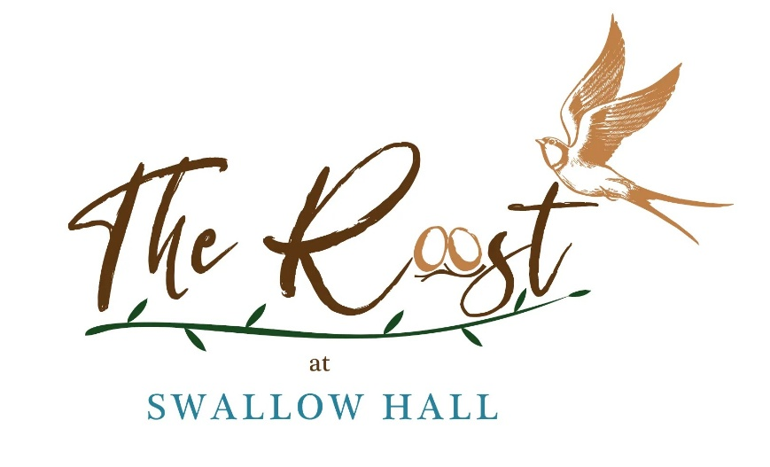

Serving a range of soft drinks & alcoholic beverages, along with a selection of sweet & savoury snacks.

Bacon & sausage sandwiches available until 2pm most weekends.

OPENING HOURS FOR DRINKS
Please see below for our current opening times.
Monday – drinks served in golf spike bar (not on bank holidays)
Tuesday – drinks served in golf spike bar
Wednesday – 10am till 6pm
Thursday – 10am till 6pm
Friday – 10am till 6pm
Saturday - 9am till 6pm
Sunday – 9am till 5:30pm

Last orders are called 15minutes prior to all times stated.

